Rapport 2 TBMI26, Filip Berglund (Filbe882) and Kasper Andersson (kasan880)

Q1

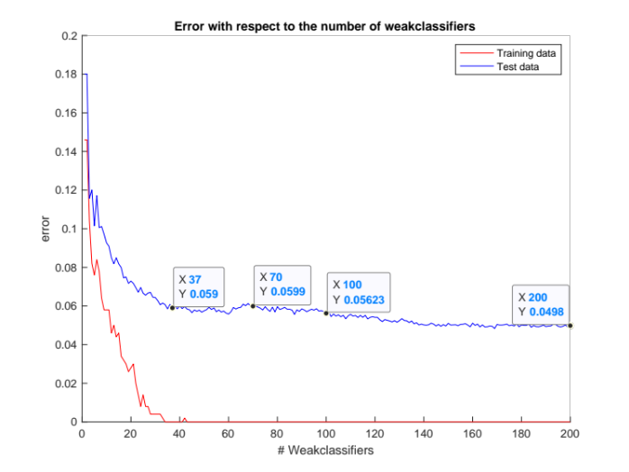

Number of faces for training: 500
Number of non-faces for training: 500

Number of faces for testing: 4416
Number of non-faces for testing: 7372

Number of Haar

Q2 Q3

We used 200 weak classifiers for training. We can observe that after around 40 weak classifiers (see picture in Q1) the result doesn’t get much better. The accuracy for test data with 40 weak classifiers is about 94% while its 100% for the training data. More than 40 weak classifiers would be a computational waste.
We used 200 Haar features, and 92 of them where used in the final strong classifier. The more Haar features choose will increase the probability that only a few of them is needed for a good result.

Q4

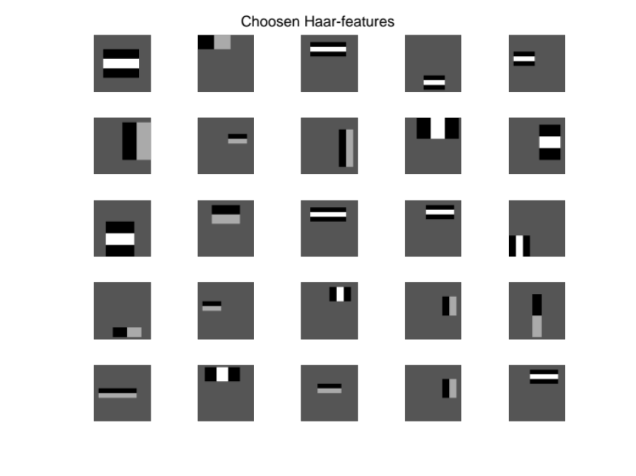
The Haar features are used to match shades in the faces. They could be used to match the nose, eye browns, cheeks etc.

Q5

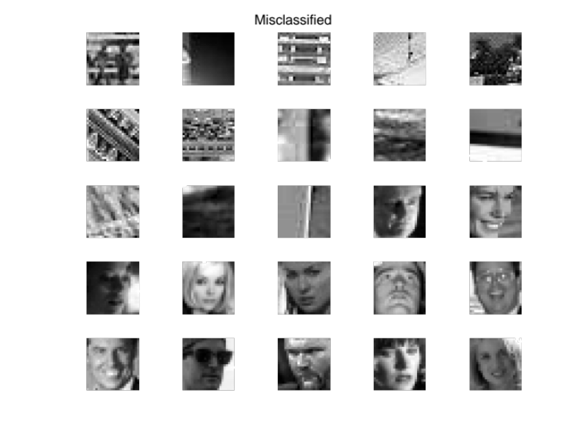

Here we have some of the misclassified pictures. For the faces classed as non-faces, this is reasonable due to some of the pictures contains glasses, are shaded or taken from an odd angle. For the non-faces classed as faces, it’s harder to tell exactly why but for example the middle picture we can see a shape that could be mistaken for a nose.

Q6

The results are reasonable. The more weak classifiers we use the lower error we get.

Q7

Since the training data is limited, the model doesn’t know all possible ways a face may appear in a picture, likewise for non-faces. We can never truly expect a perfect results, since we didn’t see all possibly faces.

